Thomas Courtney

3175353  UON

PHYS2170: Electron Diffraction

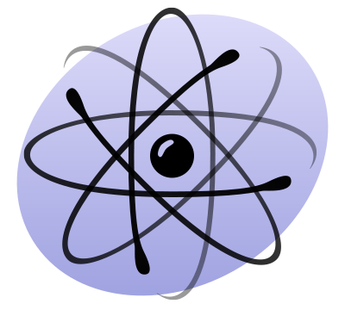

Contents

Abstract 2

Introduction 2

Procedure 4

Results 5

Discussion 6

Inaccuracy 6

Data Analysis 6

Conclusion 7

Bibliography 8

# Abstract

This report details the observation of electron diffraction through a graphite sample. Electrons were accelerated in a cathode ray tube and fired at a sample producing an interference pattern on a screen. Diffraction patterns from two crystal planes were observed. The spacing between the atoms in each plane were found to be 2.06 ± 0.25 Å and 1.37 ± 0.25 Å. This is in the same order of magnitude as credible values found, 1.54 Å [1].

# Introduction

Diffraction is a phenomenon where waveforms interacting with an obstacle are “bent” or redirected (see Figure 1). This occurs as when a waveform strikes an obstacle its path is changed, and it is deflected in another direction (diffracted).

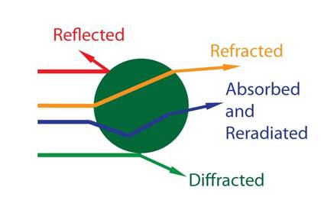

Figure 1: A waveform incident with an obstacle and the possible results.

By firing waveforms at a crystal lattice, the waves are diffracted and create an interference pattern. It is necessary for the waveform being diffracted to have a similar wavelength to the spacing it is being diffracted by in order to interact with it. The spacing is referred to as a “diffraction grating” (see Figure 2).

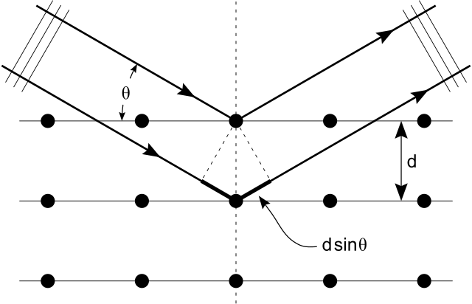

Figure 2: Diffraction of a waveform in a lattice structure.

The diffraction of a waveform in a crystal lattice is called “Bragg Diffraction” (also called “Bragg Reflection”) as it was first performed by Lawrence and William Bragg in 1913 who used X-rays. By observing the interference pattern of the light waves, they were able to determine the spacing of the diffraction grating (the molecules in the lattice). Each maxima of interference represents a “plane” of molecules in the lattice (the horizontal rows in Figure 2). The spacing between the interference maxima can then be used to calculate the spacing of the planes.

This phenomenon can be performed with electrons also, due to the wave-particle duality of quantum scale particles. Accelerating electrons using a potential difference and applying de’ Broglie’s wavelength relationship

$$λ=\frac{h}{ρ}=\frac{h}{\sqrt{2mE}}=\frac{h}{\sqrt{2mqV}}$$

$$Where q is charge, m is mass, V is potential and h is planck^{'}s constant.$$

Therefore, the wavelength of the electrons may be altered by changing the potential acting on them. By firing these electrons at a sample of graphite that consists of many different orientations of crystals an interference pattern of two rings is produced (see Figure 3). Each ring represents a plane in the lattice. Taking the diameter of each ring at each diameter and applying them to Equation 1.

$$\left(1\right) \sqrt{V}=\left[\begin{aligned}\sqrt{\frac{em}{2h^{2}}}*\frac{d}{L}\end{aligned}\right]D$$

$$Where V is accelerating potential on electrons, e is charge on electron, m is mass of electron$$

$$h is planck^{'}s constant , d is the plane spacing in Figure 2, L is the distance between the electron firing$$

$$point and screen and D is the interference ring diameter.$$

By plotting $\sqrt{V} vs D$ the gradient is the constant in Equation 1. Therefore, d may be isolated from this value and the plane spacing be found.

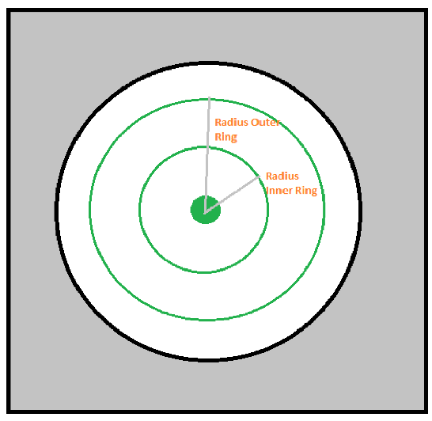

Figure 3: Electron interference pattern for graphite sample.

# Procedure

A variable voltage was applied to a cathode ray tube. Measurements of the diameter for two interference rings (see Figure 3) were taken for ten voltages. The first voltage was the lowest voltage possible while still being able to see and measure the rings. The square root of the voltage readings was plotted on the y-axis against the diameter readings of the interference rings. The spacing of the planes was derived from a linear approximation of the plots to obtain gradient and substituted into Equation 1.

See apparatus used in Figure 4.

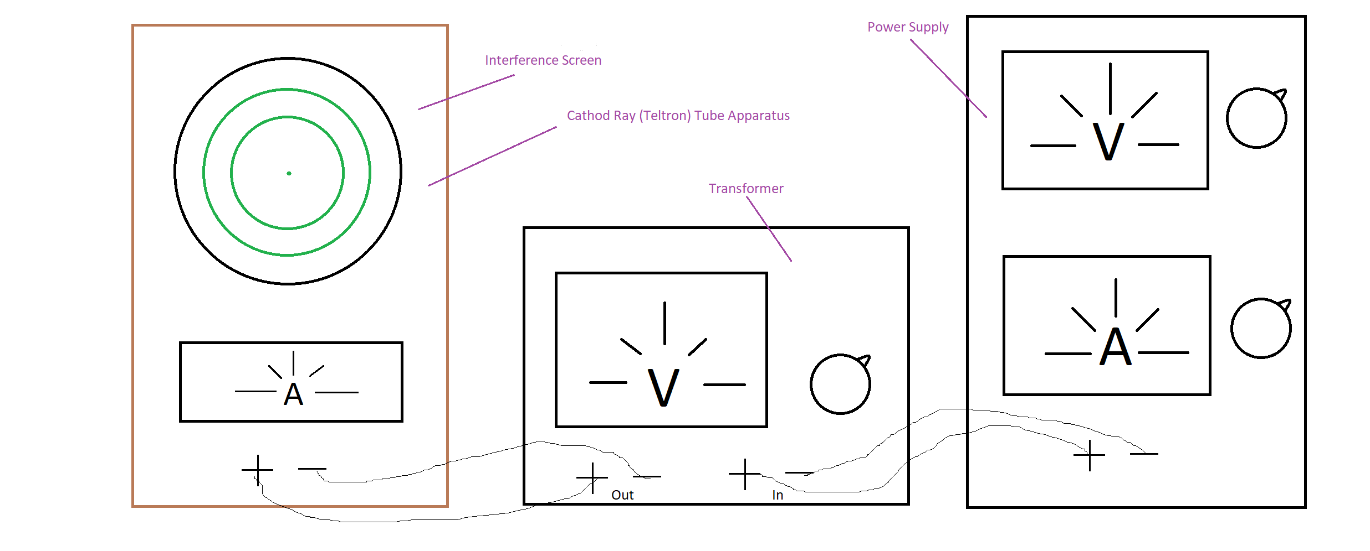

Figure : Apparatus for electron diffraction using a cathode ray tube

# Results

Figure : Change in diameter of interference rings for two planes in a graphite sample with voltage.

|  |  |
| --- | --- |
| **Plane Ring** | **Spacing (Å)** |
| Inner | 2.06 ± 0.25 |
| Outer | 1.36 ± 0.25 |

Table : Lattice spacings of two planes of a graphite sample.

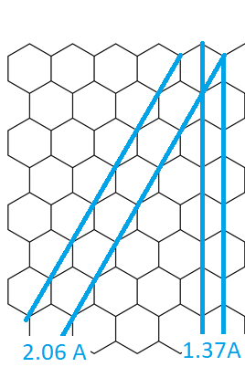

Figure 6: Hexagonal lattice structure of graphite.

# Discussion

## Inaccuracy

There were several sources of inaccuracy in this experiment. The largest inaccuracy was due to human error in measurement of the diameter of the circles. This was found to be ± 1mm which at worst was ±6.1% of a reading. Additionally, the inaccuracy of the voltage output was ±3%. These factors were summed for a total inaccuracy of ±9.1% which was applied to the gradient of the plots and carried through calculations yielding an error of ±0.25 Å in plane spacing.

Negligible contributions include the linear trendline of the graph and the uncertainty of the callipers used to measure the rings diameters. The trendline was drawn through (0,0) as this influences the trendline to reflect the control point where no voltage is applied no diffraction should occur.

## Data Analysis

The interference pattern of on the cathode ray tube screen created two rings (see Figure 3). There are only two rings present because the regular lattice of graphite has only two unique spacings (See figure 6.)

The reason it does not create an interference pattern like that of something like the two-slit experiment (see Figure 7) is because the sample consists of a very large number of randomly oriented crystals.

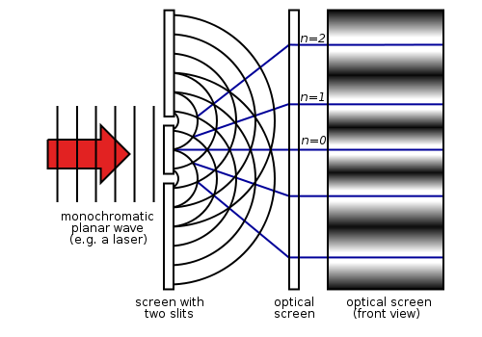

Figure : Interference pattern of two-slit experiment.

Each crystal because, they’re all the same, contribute maxima to the ring the same distance from the centre point as the other crystals. The electrons are diffracted at the same angle thus their distance from the origin is the same however due to their random orientation the position on the circumference of the ring changes. If electrons were fired only at a single crystal the interference screen would display only two dots.

The rings are a several millimetres thick as the electron velocities spread as they diffract creating some variance in where they strike the screen.

# Conclusion

Using electron diffraction through a graphite sample and measuring the interference pattern created for the crystal planes the spacing between them was found to be 2.06 ± 0.25 Å and 1.37 ± 0.25 Å. This is a reasonable answer as compared to sources that purported spacing of 1.54 Å [1]. This experiment had two large sources of inaccuracy in the voltage readings (±3%) and error in measurement (±6.1%).

# Bibliography

|  |  |
| --- | --- |
| [1] | A. Warren-Gregory, “Distance Between Carbon Atoms,” The Physics Fact Book, 2001. [Online]. Available: https://hypertextbook.com/facts/2001/AliceWarrenGregory.shtml. [Accessed May 2018]. |